The Victorian Government is making it easier for families to find approved kindergarten programs. For kinder you can count on, just look for the tick.
When it comes to making decisions about your child’s early education and care, there can be a lot to consider. We understand you want what’s best for your child and family, and to be sure about your choices. The Victorian Government is making it easier for you to find kindergarten programs that are funded and approved by the government.

That’s why we’re introducing the Kinder Tick. When you see the Kinder Tick, you can be confident:
- the program will be led by a qualified teacher
- children will benefit from play-based learning
- the kindergarten program is funded and approved by the Victorian Government
- the program complies with government guidelines and the National Quality Framework.
This is the same in both long day care and standalone kindergarten services.
No matter where your child attends a kindergarten program, they’ll be learning through play with an early childhood teacher. Research shows that play-based learning is the best way to help young children learn, develop well and prepare to thrive at school.

How do I find a kindergarten program and enrol my child?

- You can find your local participating kindergarten services at education.vic.gov.au/findaservice
- Look for the Kinder Tick at your local early childhood education service, on their building, website or in their materials, and talk to the service about their enrolment process and timelines.
- Your local area may operate a central enrolment process for some or all services. To find out more, contact your local council.

When can my child attend Four-Year-Old Kindergarten?
Four-Year-Old Kindergarten, delivered in the year before a child goes to school, is 15 hours a week of play-based learning that is available to families.

When can my child attend Three-Year-Old Kindergarten?
In Victoria, from 2022 children can access an extra year of a funded kindergarten program. Victoria is the only state or territory in the nation to introduce this reform — it’s part of an almost $5 billion investment over 10 years.
This means once a child turns three years old, they can access government-subsidised kindergarten programs. So, when your child is two years old, it is the time to think about enrolling them for the next year.
You can find out more about Three-Year-Old Kindergarten, and where it’s available, here: vic.gov.au/kinder

Why are kinder programs important?
Research shows kinder programs can set up your child to succeed, and that these benefits can last their whole lives.
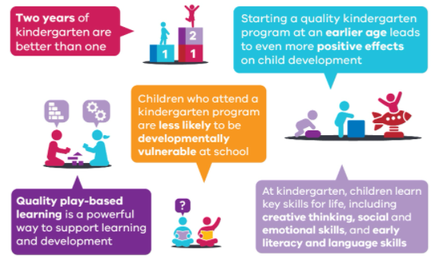

What will my child experience at a kinder program?
At kinder your child will:
- learn about the world through play
- use their imagination and practise important skills
- use play to build their language skills and learn about numbers and patterns
- learn how to get along with others, share, listen and manage their emotions.
Teachers and educators help children become curious, creative and confident about learning. They will tailor programs to suit your child’s age, needs and interests.
All kindergarten programs work with the Victorian Early Years Learning and Development Framework. You can find out more about the Framework here: education.vic.gov.au/childhood/professionals/learning/Pages/veyldf.aspx

Should I send my child to a long day care and a standalone kindergarten?
Kinder is a program, not a place. Kindergarten programs are delivered in both long day care and standalone services.
You can choose what works best for your family and child — the kindergarten programs are the same. Funded kindergarten programs in Victoria are led by qualified early childhood teachers and offer play-based learning programs based on the same government guidelines.
A long day care centre offers a full day of education and care to children from birth to school age, and many offer a funded kindergarten program as part of their service. The teacher-led kindergarten program may be integrated with additional hours of education and care. Kindergarten programs delivered in a long day care setting provide flexibility for parents and carers by offering childcare before and after the kindergarten program.
A standalone kindergarten offers up to 15 hours of a funded kindergarten program to eligible three and four-year-old children. The kindergarten program runs on certain days and at specific times.

Is the Kinder Tick a rating system?
No. The Kinder Tick helps Victorian families find a funded kindergarten program for their children. All kindergarten programs in Victoria are also independently assessed and rated under the National Quality Framework, which is a separate process. You can find descriptions of every service’s National Quality Framework rating at: startingblocks.gov.au.

What if my child’s current service doesn't display the Kinder Tick?
Using or displaying the Kinder Tick is not compulsory — it is an optional tool to help early childhood services and families in Victoria. You can check whether a funded kindergarten program is available by asking the service directly.

How much of my kindergarten fees are government funded?
The amount in kindergarten fees that each family pays can vary based on your location, the type of early childhood education service and existing government subsidies. It’s best to speak to your service directly about your fees, including any subsidies your family may be eligible for.

For more information on the Kinder Tick, visit www.vic.gov.au/kindertick
